Roles and Responsibilities

Your user role in Courseware determines your responsibilities and permissions within the application.

*Not sure what your Courseware role is?*

In each Courseware program, find your name in the upper right corner of the screen. Your role appears directly above your name. If you are a program administrator, your role may change between program admin and instructor, depending on the program you are accessing.   
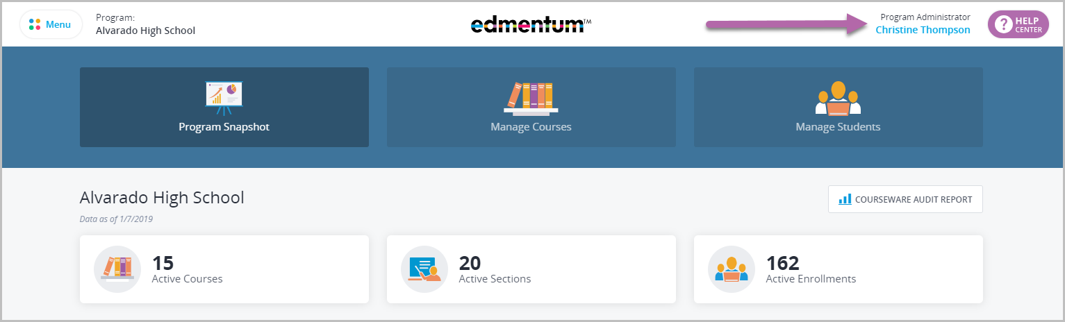

Account Administrator

Your Account Administrator is the main contact person for your organization’s Courseware account.

The Courseware Account Administrator performs the following tasks:

* Initial set up and establishing role permissions, uploading users, and distributing credentials to teachers and program administrators

Account administrator responsibilities include:

* Clearly explain the expectations for instructors in their online teaching roles.
* Understand school policies that determine which students are appropriate to enroll in the Courseware program.
* Support Courseware instructors and students with the administrative and orientation requirements for technology.
* Ensure that instructors receive appropriate training to do their jobs effectively.

Program Administrator

The Account Administrator can grant this role to any instructor in the Courseware program. A Program Administrator oversees program-level implementations, including:

* Create new users.
* Manage student status with enrollment and withdrawal.
* Manage the course catalog for designated programs.
* Create customized courses using Custom Course Builder.

Read-Only Program Administrator

As the name suggests, this role is designed for individuals who need viewing access to student progress and data, but do not need editing access. It is ideal for counselors, assistant principals or principals, and program auditors. This role:

* Can view all students in the assigned programs(s) and run reports.
* Cannot take actions on students or course sections.

Only **account administrators** can create read-only program administrators. Once this role is assigned, it CANNOT be changed to another user role (such as instructor or regular program administrator).

Instructor

As an instructor, you facilitate and monitor student learning using Courseware’s online courses, learning platform, and communication tools. If the setting is enabled by the account administrator, you may also be able to create course sections and add students to your own sections.

Read-Only Instructor

Created to provide transparency to educators invested in program outcomes while protecting the fidelity of the implementation, the Read-Only Instructor role is very similar to the Read-Only Program Administrator (see above).

It allows an educator to view the course sections in which they are enrolled. The Read-Only Instructor can view student data and generate reports but cannot edit course section or student information.